|  |  |
| --- | --- |
| siit-logo.png | **ȘCOALA INFORMALĂ DE IT**  FRONT-END WEB DEVELOPMENT (JAVASCRIPT) |

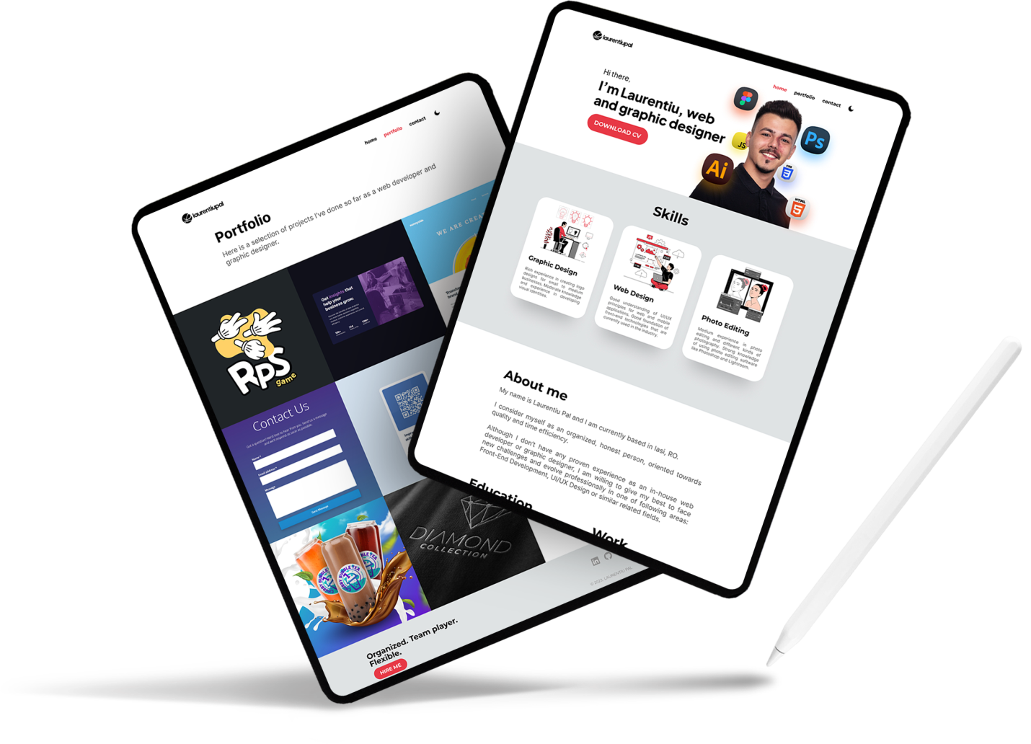

My •Online CV

|  |  |
| --- | --- |
| **COORDINATOR**  Andrei DASCAL | **GRADUATE**  Laurentiu-Petru PAL |

2023

TABLE OF CONTENTS

1. INTRODUCTION 1

1.1. Objective 1

1.2. Scope 1

2. RESEARCH AND INSPIRATION 1

2.1. Trends 1

2.2. Usability 2

2.3. Inspiration 5

3. WEBSITE LAYOUT 6

3.1. Low fidelity wireframe 6

3.2. Medium fidelity wireframe 8

3.3. High fidelity wireframe 10

3.4. Common areas 12

3.5. Responsiveness 13

3.6. Architecture 13

4. TECHNOLOGIES AND APPLICATIONS USED 14

5. WEBSITE FEATURES 15

5.1. Dark mode 15

5.2. Responsiveness 15

6. TASKS 15

7. BIBLIOGRAPHY 16

# INTRODUCTION

"My Online CV" project summarizes the knowledge and skills in the field of code writing and programming, acquired in the professional training course "Web Development (Javascript)" from the "IT Informational School".

## Objective

The goal of this project is to put the knowledge learned in the course into practice while also presenting personal information (professional and academic) that could be considered when applying for vacant positions in this industry.

## Scope

This project's goal is to break into the IT industry by showcasing a strong portfolio and a well-organized CV to businesses that are looking for junior front-end programmers.

# RESEARCH AND INSPIRATION

The role of research is to collect information and implement in the final product, existing concepts that already work, or more aspirational ideas (like prototypes).

## Trends

We can identify some common characteristics between websites today, including the most popular in social media, by analyzing the approach to the user, the user experience and the user interface. In my research, I've concentrated on the UI components and discovered that there are numerous common components, including:

* Rounded corners for buttons, forms, tables and other similar elements;
* Self-explanatory icons for actionable buttons/links;
* Big welcoming headline/title alongside with CTA button in the header section;
* Friendly user interface for a better user experience;
* Responsiveness across multiple devices;
* Toggle buttons for enabling/disabling specific options;
* Tooltips for certain words or components – tooltips are pop-up elements that provide additional information when the user hovers over a specific word/component;
* Chips and tags for faster sorting and filtering;
* Carousel card – usually composed by an image, a heading, a paragraph and sometimes a button.

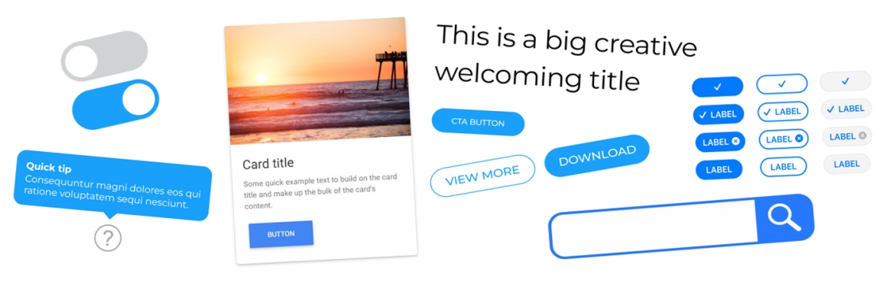

Figure – Common UI elements

## Usability

In order to have a good research for your project, you must keep the customer in mind when creating a product. Consider utilizing the product from his point of view and identify any potential issues.

In my instance, the final outcome is a specialized portfolio website that primarily targets potential clients, employers, and technical recruiters in this industry. Statistics on browser, device, OS, and screen resolution usage make up the usability research.

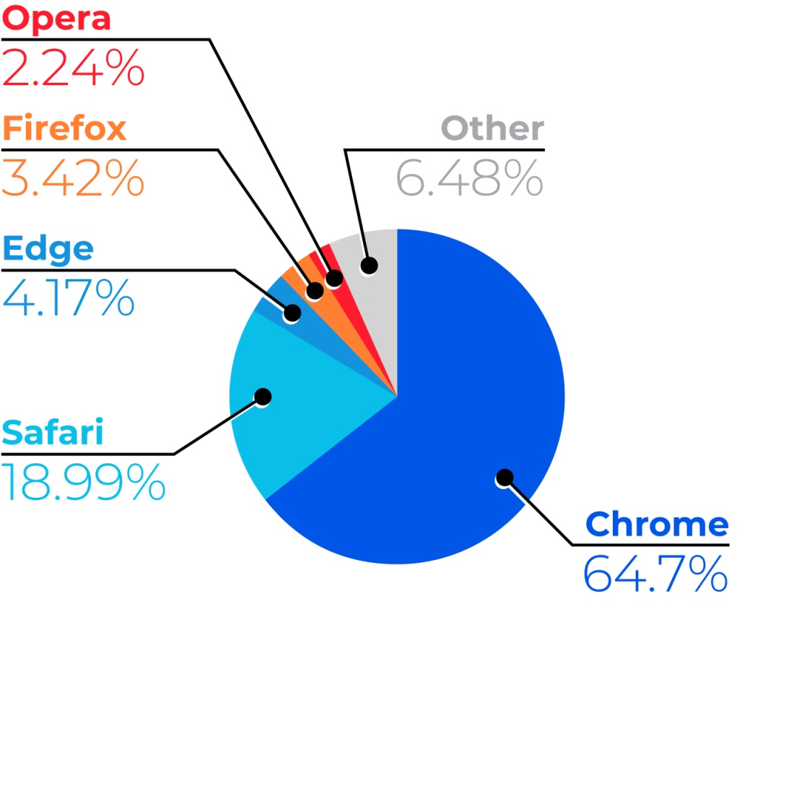

Figure - Browser Usage Statistics (NOV 2021 - DEC 2022)

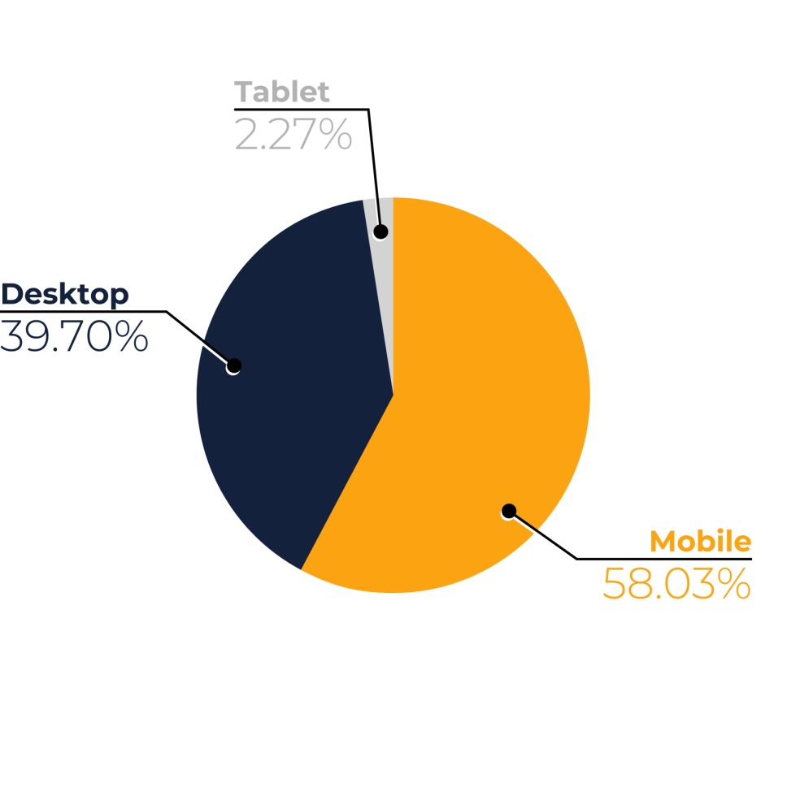

Figure - Device Usage Statistics (NOV 2021 - DEC 2022)

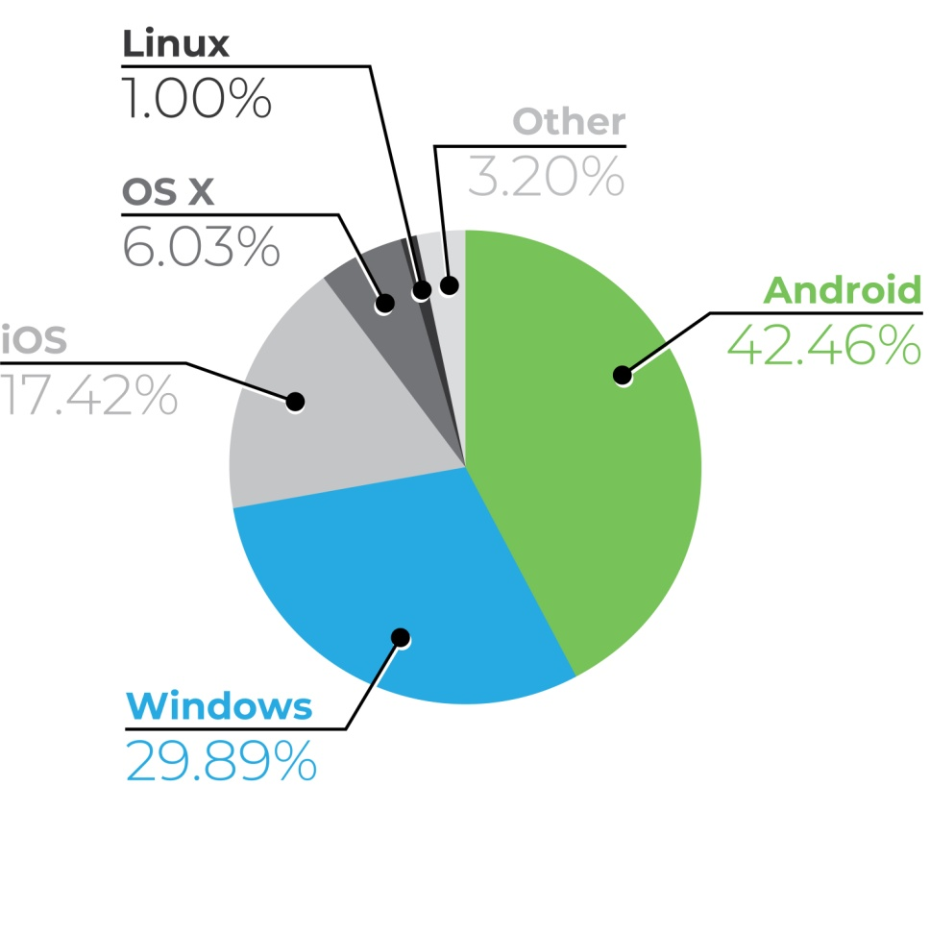

Figure – OS Statistics (NOV 2021 - DEC 2022)

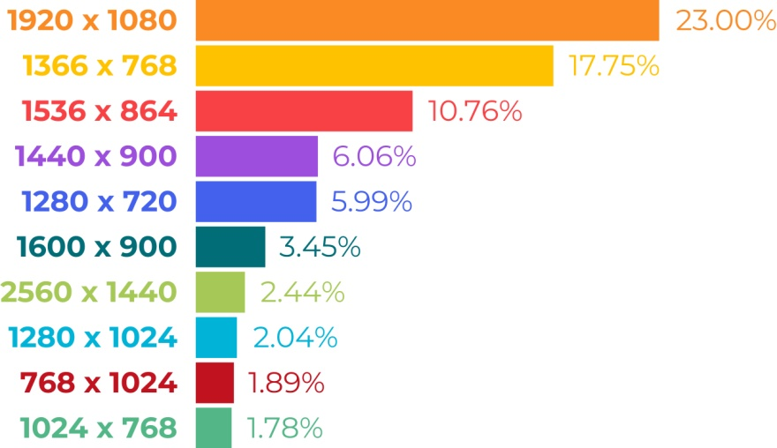

Figure – Desktop Screen Resolution Statistics (NOV 2021 - DEC 2022)

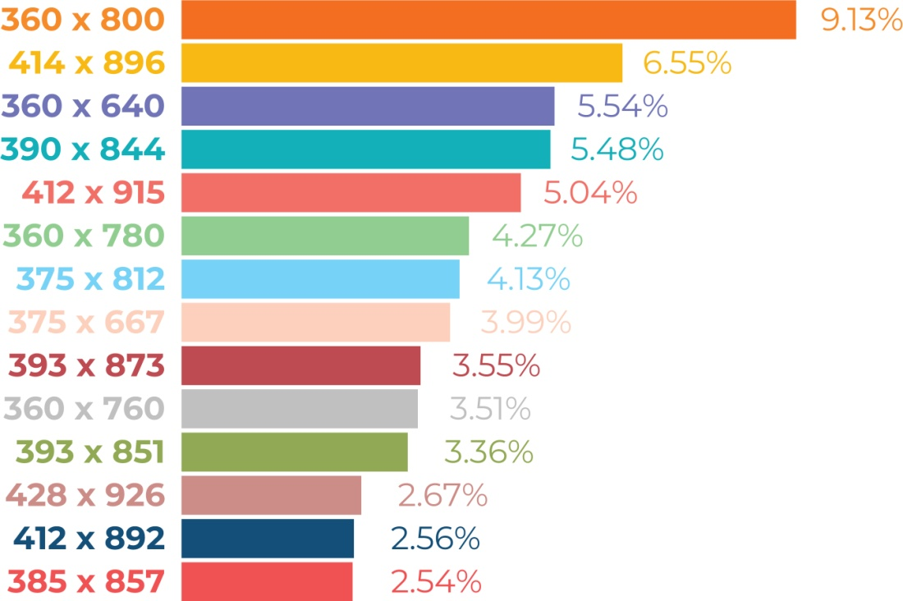

Figure - Mobile Screen Resolution Statistics (NOV 2021 - DEC 2022)

## Inspiration

|  |  |
| --- | --- |
| https://cdn.dribbble.com/users/1774675/screenshots/15176184/media/5e20e623c2736609060eb9f9e8683ba5.png?compress=1&resize=1000x750&vertical=top  Figure - Website template (inspiration) | https://cdn.dribbble.com/users/5547644/screenshots/19974342/media/acff923248f1fe382780c031d98f5031.png  Figure - Website template (inspiration) |

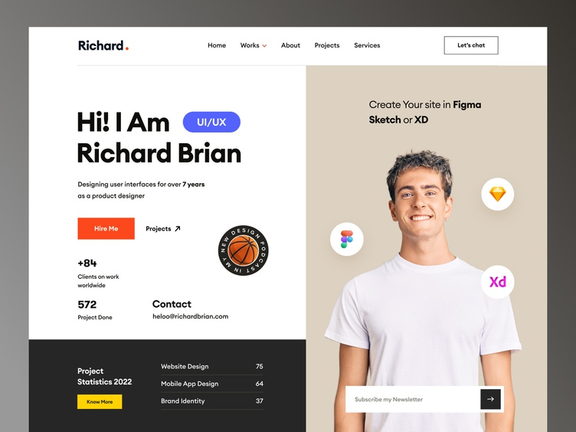

Figure - Website template (inspiration)

# WEBSITE LAYOUT

Three pages will make up the website: home, portfolio, and contact. There should be clear navigation between pages.

## Low fidelity wireframe

Low-fidelity wireframes are rough sketches of the product that help ideas become more tangible. Its main objective is to provide a quick peek of the webpage's “big picture”.

The wireframe's components, including images, headings, paragraphs, and buttons, are sketched on paper using rectangles and lines.

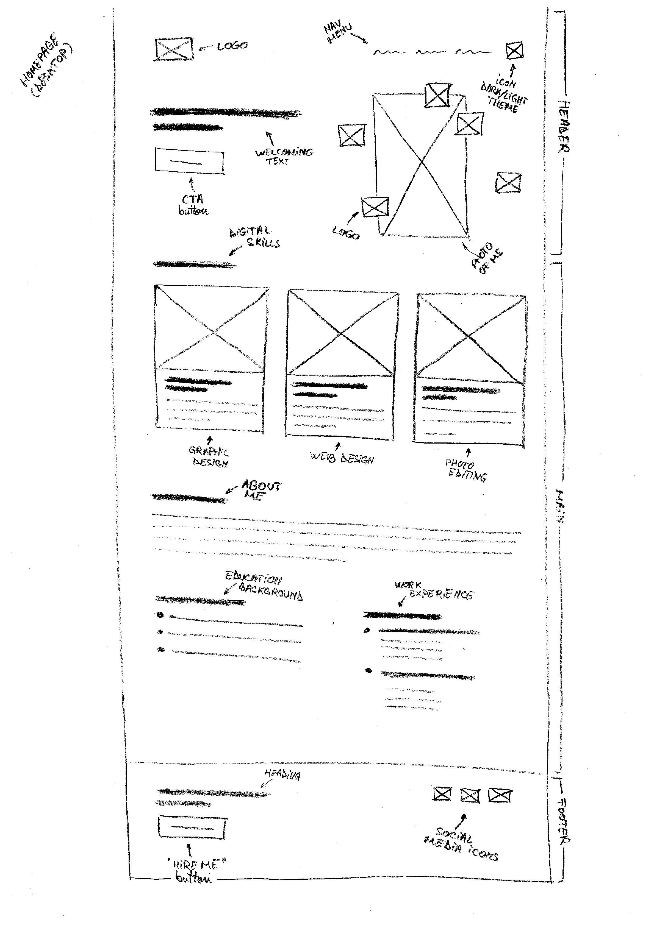

Figure - Low fidelity Wireframe (Desktop)

|  |  |  |  |
| --- | --- | --- | --- |
| 02 Desktop - Portfolio (lo-fi).jpg  Figure – Low-fidelity Wireframe (Desktop) | 03 Desktop - Portfolio item (lo-fi).jpg  Figure – Low-fidelity Wireframe (Desktop) | | 04 Desktop - Contact (lo-fi).jpg  Figure – Low-fidelity Wireframe (Desktop) |
| 05 Mobile - Homepage - Portfolio (lo-fi).jpg  Figure – Low-fidelity Wireframes (Mobile) | | 06 Mobile - Portfolio item - Contact - Nav menu (lo-fi).jpg  Figure – Low-fidelity Wireframes (Mobile) | |

## Medium fidelity wireframe

Medium fidelity wireframe represents a digital version of the low fidelity wireframe. Its purpose is to better communicate the trajectory of the project to the teams involved in the development of the product.

Images, forms, sections, and buttons are all represented in grayscale at this stage. To speed up the process, headings and paragraphs are written using dummy text (e.g. Lorem Ipsum).

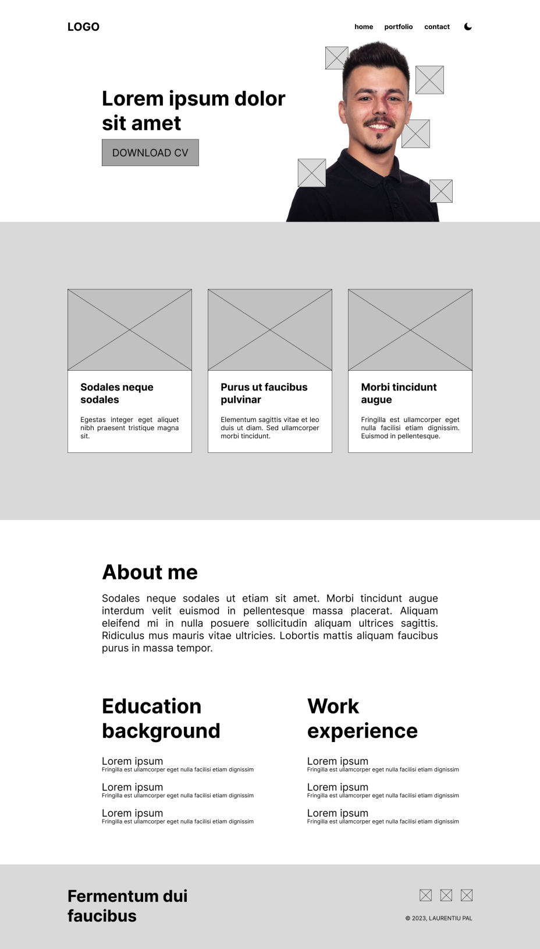

Figure – Medium-fidelity Wireframe (Desktop)

|  |  |  |  |  |  |  |
| --- | --- | --- | --- | --- | --- | --- |
| 02 Desktop - Portfolio (med-fi).png  Figure - Medium-fidelity Wireframe (Desktop) | | 03 Desktop - Portfolio item (med-fi).png  Figure - Medium-fidelity Wireframe (Desktop) | | | 04 Desktop - Contact (med-fi).png  Figure - Medium-fidelity Wireframe (Desktop) | |
| 05 Mobile - Homepage (med-fi).png  Figure - Medium-fidelity Wireframe (Mobile) | 06 Mobile - Portfolio (med-fi).png  Figure - Medium-fidelity Wireframe (Mobile) | | 07 Mobile - Portfolio item (med-fi).png  Figure - Medium-fidelity Wireframe (Mobile) | 08 Mobile - Contact (med-fi).png  Figure - Medium-fidelity Wireframe (Mobile) | | 09 Mobile - Navigation menu (med-fi).png  Figure - Medium-fidelity Wireframe (Mobile) |

## High fidelity wireframe

High fidelity wireframe takes more time to create, but it is effective on the long term because it clearly communicates to the client and developers the final aspect of the product and eliminates any concerns they might have about fine details like spacing, font sizes, border radius, and so on.

Although creating a high fidelity wireframe takes more time to create, it is more efficient in the long run because it communicates to the client the final aspect of the product more clearly and allows developers to work more effortlessly, focusing more on the code.

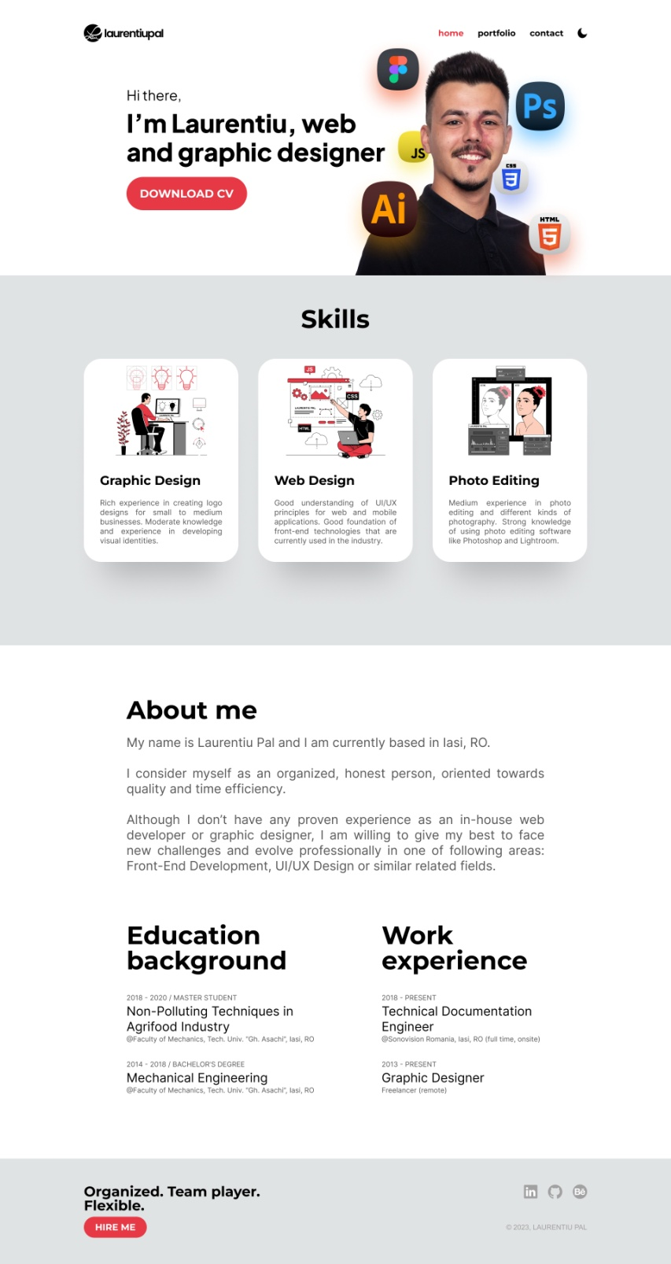

Figure - High-fidelity Wireframe (Desktop)

|  |  |  |  |  |  |  |
| --- | --- | --- | --- | --- | --- | --- |
| 02 Desktop - Portfolio (med-fi).png  Figure 26 - High-fidelity Wireframe (Desktop) | | 03 Desktop - Portfolio item (med-fi).png  Figure - High-fidelity Wireframe (Desktop) | | | 04 Desktop - Contact (med-fi).png  Figure 28 - High-fidelity Wireframe (Desktop) | |
| 05 Mobile - Homepage (med-fi).png  Figure - High-fidelity Wireframe (Mobile) | 06 Mobile - Portfolio (med-fi).png  Figure - High-fidelity Wireframe (Mobile) | | 07 Mobile - Portfolio item (med-fi).png  Figure 31 - High-fidelity Wireframe (Mobile) | 08 Mobile - Contact (med-fi).png  Figure 32 - High-fidelity Wireframe (Mobile) | | 09 Mobile - Navigation menu (med-fi).png  Figure 33 - High-fidelity Wireframe (Mobile) |



Figure 4 - Color Palette

## Common areas

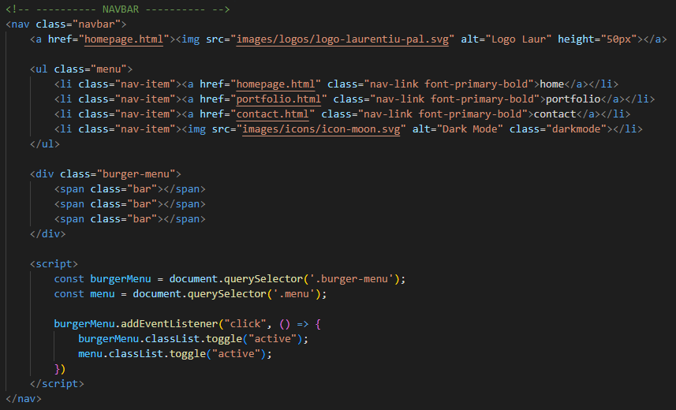

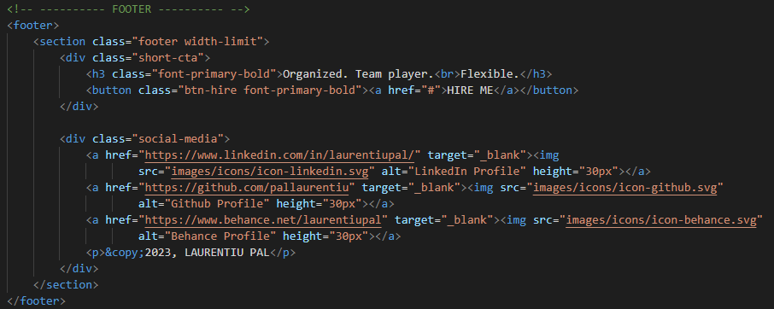

## Responsiveness

Responsive design allows your website content to flow freely across all screen resolutions and sizes, and renders it to look great on all devices. It also makes it unnecessary to maintain different versions of your website for mobile and desktop and saves you time, resources and efforts.

A modern-looking, mobile-friendly, and fast website is a prerequisite to growing your business and attracting new customers. It makes your online presence more solid and shows you as more trustworthy to your customers.

In other words, we can say that responsive design provides a better mobile experience for users and improves the general UX on pages.

## Architecture

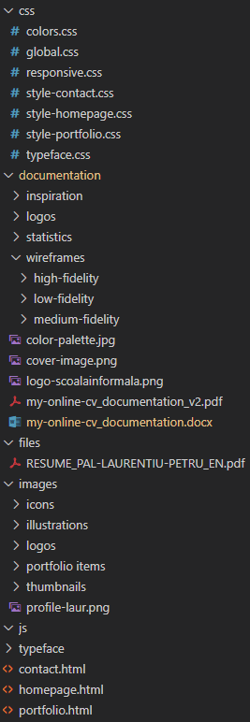

# TECHNOLOGIES AND APPLICATIONS USED

In this project I’ve used two of the primary technologies for creating web pages, which are: HTML (the Hypertext Markup Language) and CSS (Cascading Style Sheets). While **CSS** is in charge of the page's layout and aesthetics, **HTML** defines the structure of the page.

 

For some functionalities, **Javascript** was used to give additional dynamic features. All the code was written using **Visual Studio Code**.

 

**Git repository** system is an excellent backup solution that offers complete control over the versions of any web design project in different phases, which is why I've use it to keep track of my work, on **Github** platform.

 

Medium and high wireframes were done using **Figma**. Figma is a powerful design tool that helps graphic designers create user interfaces and prototypes for websites and mobile applications.



Some images and other graphic elements (e.g. icons, logo) were manipulated, edited or created using **Adobe Photoshop** and **Adobe Illustrator**.

 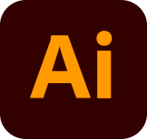

**Trello** was used for the organization part, which is a project management tool intended to help teams (or individuals) keep track of tasks/projects like this one.



# WEBSITE FEATURES

## Dark mode

Dark mode – also called “black mode”, “dark theme”, “night mode”, or “lights-out mode” – is an increasingly popular stylistic theme for websites and apps. It is a website treatment that involves replacing the classic white background, black text look of a website with a dark background and a lighter colored text, in other words, we can say that is a dark color scheme for the UI of websites and apps.

Many apps now make it possible to switch between light mode and dark mode. Some users enjoy switching between the two just to change things up, or to adjust their device’s visibility at various times of day.

Pros and Cons of dark mode:

* Dark mode may decrease eye strain in low-light conditions.
* Dark mode may decrease eye strain in low-light conditions.
* Dark mode can improve accessibility for individuals with light sensitivity.
* Dark mode may lower or eliminate screen flickering, potentially increasing focus.
* Dark mode improves battery life on devices with OLED screens.
* Dark colors can evoke negative emotions connected with sadness, mourning, or depression.
* Dark mode may increase eye strain in brightly-lit conditions.
* Dark mode does not improve battery life on older devices without OLED screens.

## Responsiveness

The concept of responsive web design is that design and development need to adapt to the environment and behavior of users, based on factors such as screen size, platform, and orientation.

In terms of Web design and development, we're rapidly approaching the point where we can no longer keep up with the never-ending new resolutions and devices. It would be impossible or at the very least impractical to create a website version for every resolution and new device that releases.

# TASKS

* Research and inspiration – 4 days
* Sketch low fidelity wireframe – 1 day
* Create medium fidelity wireframe (Figma) – 1 day
* Design high fidelity wireframe (Figma) – 1 day
* Define structure (HTML) – 2 days
* Style structure (CSS) – 3 days
* Add interactions and special functionalities (Javascript) – 3 days
* Manual testing (unit testing, usability testing) – 1 day

# BIBLIOGRAPHY

[1] mentormate, Low Fidelity Wireframes vs High Fidelity Wireframes, <https://mentormate.com/blog/low-fidelity-wireframes-vs-high-fidelity-wireframes/>

[2] Vitaly Fiedman, Responsive Web Design: What It Is And How To Use It, 2018, <https://www.smashingmagazine.com/2011/01/guidelines-for-responsive-web-design/>

[3] Claire Grace, Why You Should Consider Dark Mode for Your Next Web Design Project, 2022, <https://www.madebyspeak.com/blog/posts/why-you-should-consider-dark-mode-for-your-next-web-design-project>

[4] Dalia Goldberg, Dark Mode: All the Pros and Cons to Consider, 2021, <https://www.vectornator.io/blog/dark-mode/>

[5] Mohammad Moshin, Website Design Research – Why Is Necessary and Important?, <http://mandmwebsolutions.com/blog/web-design-process-research-and-planning/>

[6] Katalon, What is Web Testing? Types of Web Application Testing, <https://katalon.com/resources-center/blog/types-of-web-testing>

[7] Jaye Hannah, An Introduction to Color Theory and Color Palettes, 2022, <https://careerfoundry.com/en/blog/ui-design/introduction-to-color-theory-and-color-palettes/>

[8] freeCodeCamp, Divide and Conquer Algorithm Meaning: Explained with Examples, 2019, <https://www.freecodecamp.org/news/divide-and-conquer-algorithms/>

[9] Gabrien Symons, Delightful ways to write reusable CSS using subclasses, 2019, <https://medium.com/insider-inc-engineering/delightful-ways-to-write-reusable-css-using-subclasses-903e90c9cf87>

[9] statcounter, Browser Market Share Worldwide, <https://gs.statcounter.com/browser-market-share>

[10] statcounter, Desktop vs Mobile vs Tablet Market Share Worldwide, <https://gs.statcounter.com/platform-market-share/desktop-mobile-tablet>

[11] statcounter, Operating System Market Share Worldwide, <https://gs.statcounter.com/os-market-share>

[12] statcounter, Screen Resolution Stats Worldwide, <https://gs.statcounter.com/screen-resolution-stats>